LAB EXPERIMENTS
TOOL: R Programming RegisterNo:192424189
Name: Dhanusha D Date:20-07-2026 COURSE: Data Handling and Visualization Code: DSA0604 SET-6
Question 1: Grouped Bar Chart R PROGRAM:
library(ggplot2) library(tidyr)
sales <- data.frame(
Product = c("Product A","Product B","Product C"), January = c(2000,1500,1200),
February = c(2200,1800,1400), March = c(2400,1600,1100)
)
sales_long <- pivot_longer( sales,
cols = January:March, names_to = "Month", values_to = "Sales"
)
ggplot(sales_long, aes(x = Product,
y = Sales,
fill = Month)) + geom_bar(stat = "identity",
position = "dodge") +
labs(
title = "Monthly Product Sales (First Quarter)", x = "Product",

y = "Sales"
) +
theme_minimal()

OUTPUT:
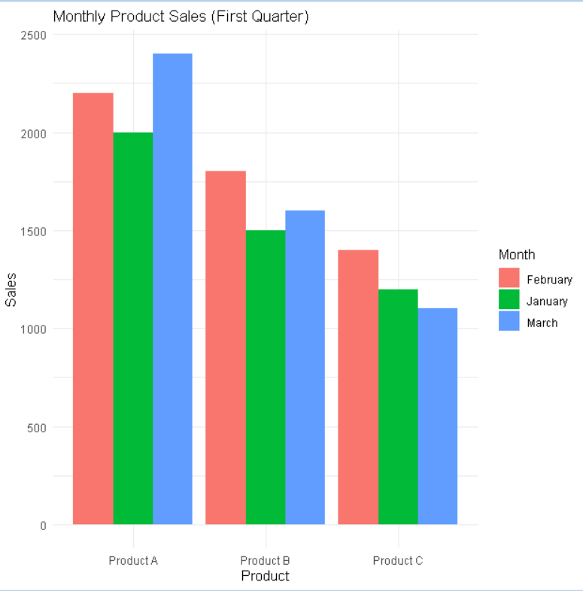

Question 2: Stacked Area Chart R PROGRAM:
library(ggplot2) library(tidyr)
sales <- data.frame(
Month = c("January","February","March"), ProductA = c(2000,2200,2400),
ProductB = c(1500,1800,1600), ProductC = c(1200,1400,1100)
)
sales_long <- pivot_longer( sales,
cols = ProductA:ProductC, names_to = "Product", values_to = "Sales"

)
ggplot(sales_long, aes(x = Month,
y = Sales,
fill = Product, group = Product)) +
geom_area() + labs(
title = "Overall Sales Trend", x = "Month",
y = "Sales"
) +
theme_minimal()
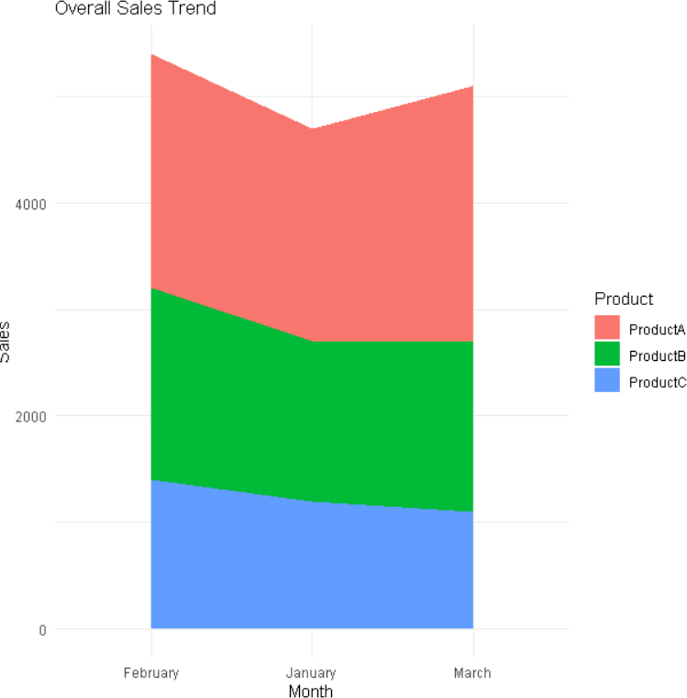

Question 3: Monthly Sales Table R PROGRAM:
sales <- data.frame( ProductID = c(1,2,3),
ProductName = c("Product A","Product B","Product C"),

JanuarySales = c(2000,1500,1200), FebruarySales = c(2200,1800,1400), MarchSales = c(2400,1600,1100)
)
print(sales)
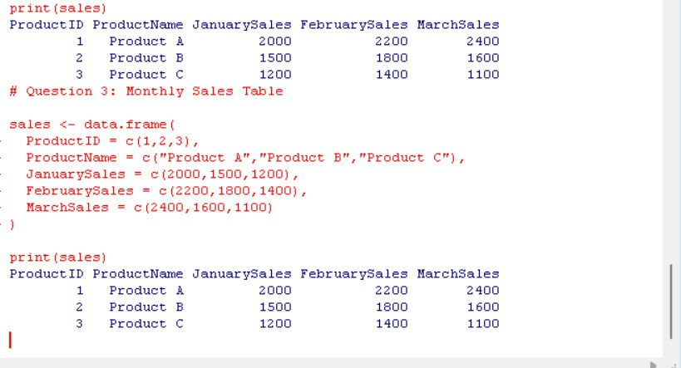
Question 4: Interactive Dashboard (Shiny + Plotly) R PROGRAM:
library(shiny) library(plotly) library(tidyr)

sales <- data.frame(
Product = c("Product A","Product B","Product C"), January = c(2000,1500,1200),
February = c(2200,1800,1400), March = c(2400,1600,1100)
)

sales_long <- pivot_longer(

sales,
cols = January:March, names_to = "Month", values_to = "Sales"
)

ui <- fluidPage(

titlePanel("Product Sales Dashboard"),

fluidRow(

column( 6,
plotlyOutput("barPlot")
),

column( 6,
plotlyOutput("areaPlot")
)

),

br(),

tableOutput("salesTable")

)

server <- function(input, output){ output$barPlot <- renderPlotly({ plot_ly(
sales_long,
x = ~Product, y = ~Sales,
color = ~Month, type = "bar"
) %>%
layout(barmode = "group")

}) output$areaPlot <- renderPlotly({ plot_ly(
sales_long, x = ~Month, y = ~Sales,
color = ~Product, type = "scatter", mode = "lines", stackgroup = "one"
)
})
output$salesTable <- renderTable({ sales
})
}
shinyApp(ui, server)

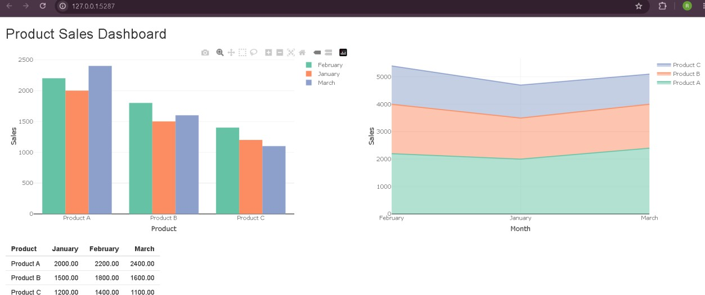

SET-7

Question 1: Bar Chart - Customer Age Distribution R PROGRAM:
library(ggplot2) customers <- data.frame( CustomerID = c(1,2,3), Age = c(28,35,42),
Gender = c("Female","Male","Female"), Income = c(50000,60000,75000)
)
ggplot(customers,
aes(x = factor(CustomerID), y = Age,
fill = factor(CustomerID))) + geom_bar(stat = "identity") + labs(
title = "Customer Age Distribution", x = "Customer ID",
y = "Age (Years)"
) +

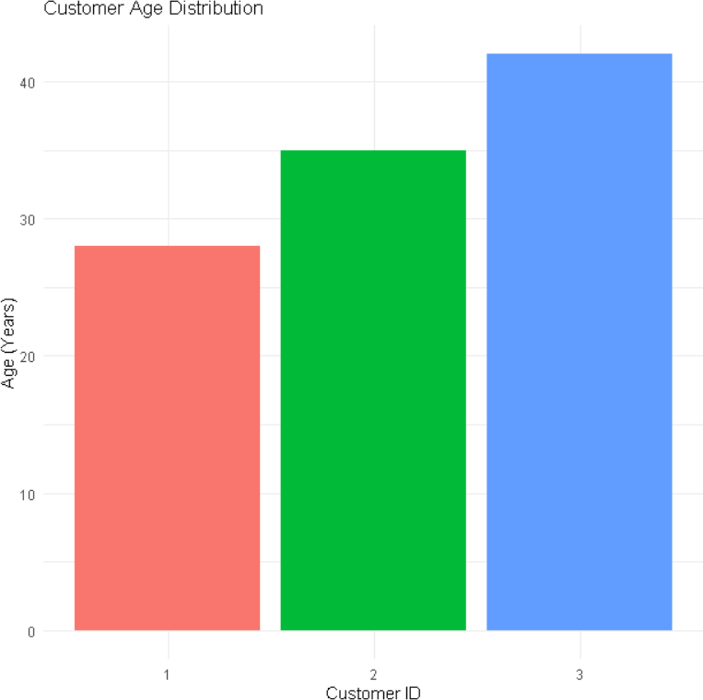
theme_minimal() + theme(legend.position = "none")

Question 2: Pie Chart - Gender Distribution R PROGRAM
library(ggplot2) customers <- data.frame(
Gender = c("Female","Male","Female")
)
gender_count <- as.data.frame(table(customers$Gender)) colnames(gender_count) <- c("Gender","Count") ggplot(gender_count,
aes(x = "",
y = Count,
fill = Gender)) +
geom_bar(stat = "identity", width = 1) + coord_polar("y") +
labs(

title = "Customer Gender Distribution"
) +
theme_void()
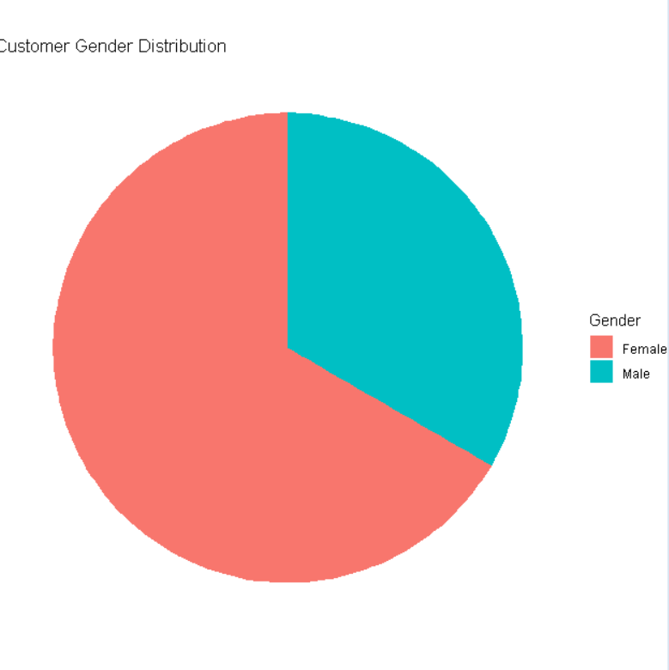

Question 3: Customer Demographics Table R PROGRAM:
customers <- data.frame( CustomerID = c(1,2,3), Age = c(28,35,42),
Gender = c("Female","Male","Female"), Income = c(50000,60000,75000)
)
print(customers)

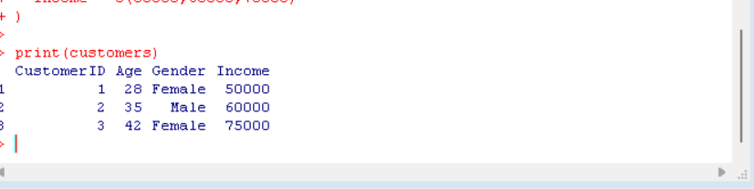
Question 4: Interactive Dashboard (Shiny + Plotly) R PROGRAM:
library(shiny) library(plotly)
customers <- data.frame( CustomerID = c(1,2,3), Age = c(28,35,42),
Gender = c("Female","Male","Female"), Income = c(50000,60000,75000)
)
gender_count <- as.data.frame(table(customers$Gender)) colnames(gender_count) <- c("Gender","Count")
\ui <- fluidPage(
titlePanel("Customer Demographics Dashboard"), fluidRow(
column(
6,
plotlyOutput("barPlot")
),

column( 6,
plotlyOutput("piePlot")
)

),

br(),

tableOutput("customerTable")

)server <- function(input, output){ output$barPlot <- renderPlotly({ plot_ly(
customers,
x = ~factor(CustomerID), y = ~Age,
type = "bar",
color = ~factor(CustomerID)
)
})output$piePlot <- renderPlotly({ plot_ly(
gender_count, labels = ~Gender, values = ~Count, type = "pie"
)
})

output$customerTable <- renderTable({ customers
})
}
shinyApp(ui, server)

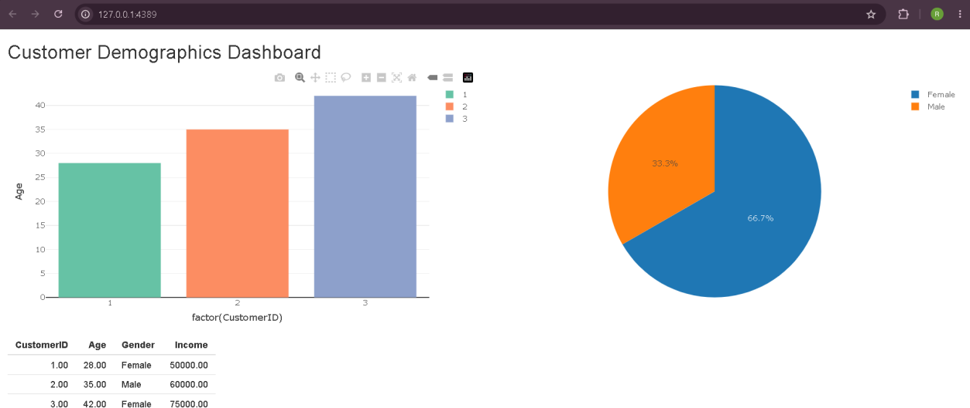

SET-8

Question 1: Line Chart - Employee Performance Trend R PROGRAM:
library(ggplot2) employee <- data.frame( EmployeeID = c(1,2,3),
Department = c("Sales","HR","Marketing"), YearsOfService = c(5,3,7), PerformanceScore = c(85,92,78)
)
ggplot(employee,
aes(x = YearsOfService, y = PerformanceScore, group = 1)) +
geom_line(color = "blue", linewidth = 1.2) + geom_point(color = "red", size = 3) +
labs(
title = "Employee Performance Trend", x = "Years of Service",
y = "Performance Score"

) +

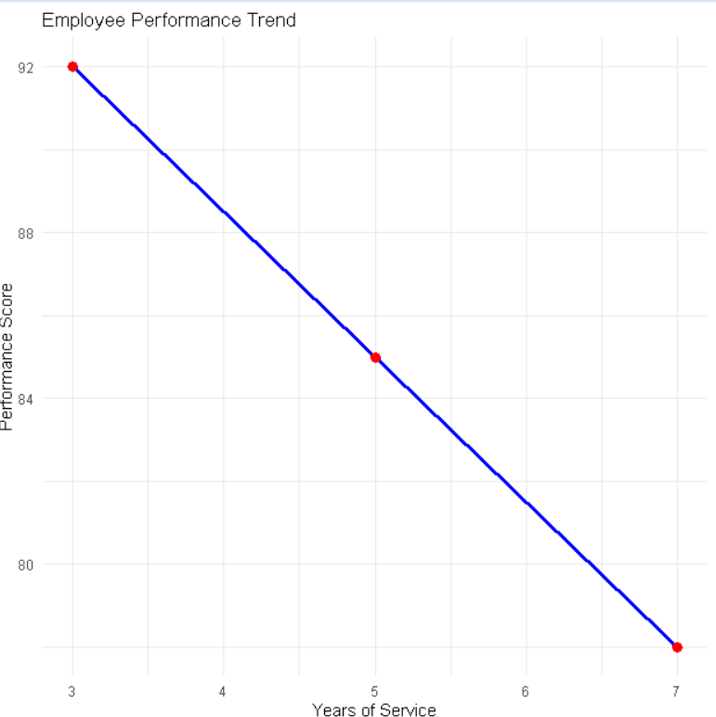

Question 2: Bar Chart - Employees by Department R PROGRAM:
library(ggplot2) employee <- data.frame(
Department = c("Sales","HR","Marketing")
)
dept_count <- as.data.frame(table(employee$Department)) colnames(dept_count) <- c("Department","Count") ggplot(dept_count,
aes(x = Department, y = Count,
fill = Department)) + geom_bar(stat = "identity") +

labs(
title = "Employees by Department", x = "Department",
y = "Number of Employees"
) +
theme_minimal()
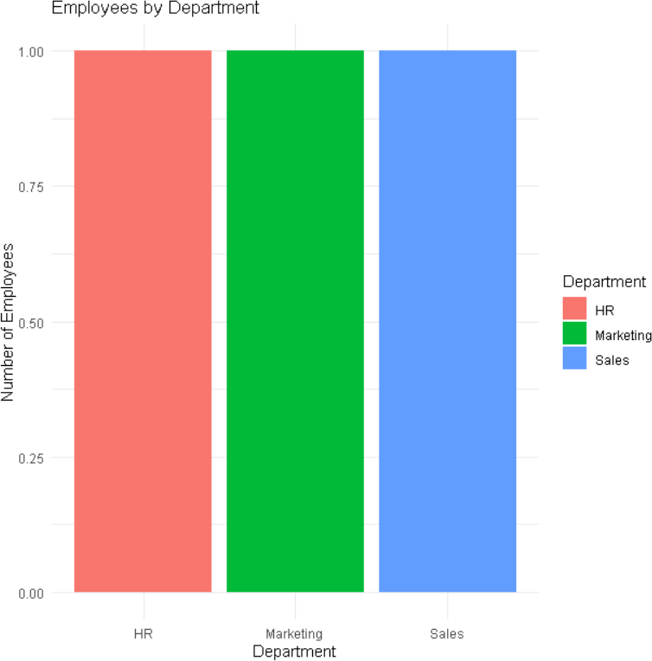

Question 3: Employee Performance Table R PROGRAM:
employee <- data.frame( EmployeeID = c(1,2,3),
Department = c("Sales","HR","Marketing"), YearsOfService = c(5,3,7), PerformanceScore = c(85,92,78)
)
print(employee)

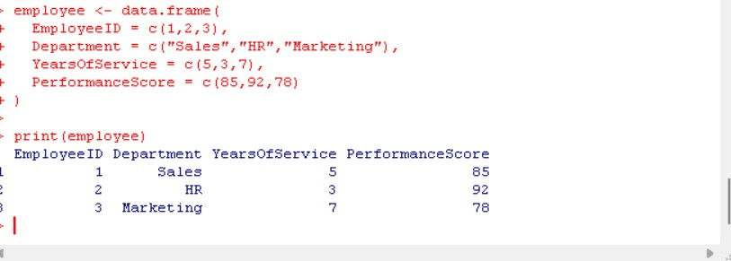
Question 4: Interactive Dashboard (Shiny + Plotly) R PROGRAM:
library(shiny) library(plotly)
employee <- data.frame( EmployeeID = c(1,2,3),
Department = c("Sales","HR","Marketing"), YearsOfService = c(5,3,7), PerformanceScore = c(85,92,78)
)
dept_count <- as.data.frame(table(employee$Department)) colnames(dept_count) <- c("Department","Count")
ui <- fluidPage(
titlePanel("Employee Performance Dashboard"), fluidRow(
column( 6,
plotlyOutput("linePlot")
),
column( 6,
plotlyOutput("barPlot")
)

),
br(), tableOutput("employeeTable")) server <- function(input, output){ output$linePlot <- renderPlotly({ plot_ly(
employee,
x = ~YearsOfService,
y = ~PerformanceScore, type = "scatter",
mode = "lines+markers"
)
})
output$barPlot <- renderPlotly({ plot_ly(
dept_count,
x = ~Department, y = ~Count,
type = "bar",
color = ~Department
)
})
output$employeeTable <- renderTable({ employee
})
}
shinyApp(ui, server)

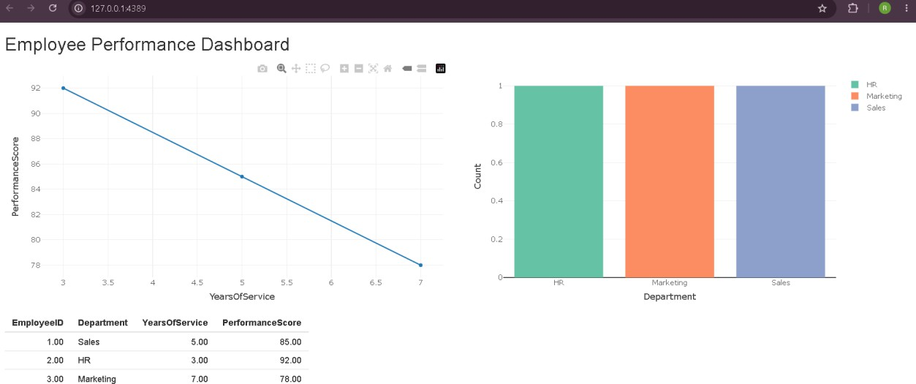

SET -9

Question 1: Import Dataset, Histogram & Boxplot R PROGRAM:
library(ggplot2)
data <- read.csv("Online_Learning_Activity.csv") ggplot(data, aes(x = Quiz_Score)) + geom_histogram(binwidth = 5,
fill = "skyblue", color = "black") +
labs(
title = "Distribution of Quiz Scores", x = "Quiz Score",
y = "Frequency"
) +
theme_minimal() ggplot(data,
aes(x = Course,
y = Quiz_Score, fill = Course)) +
geom_boxplot() +

labs(
title = "Quiz Score by Course", x = "Course",
y = "Quiz Score"
) +
theme_minimal()
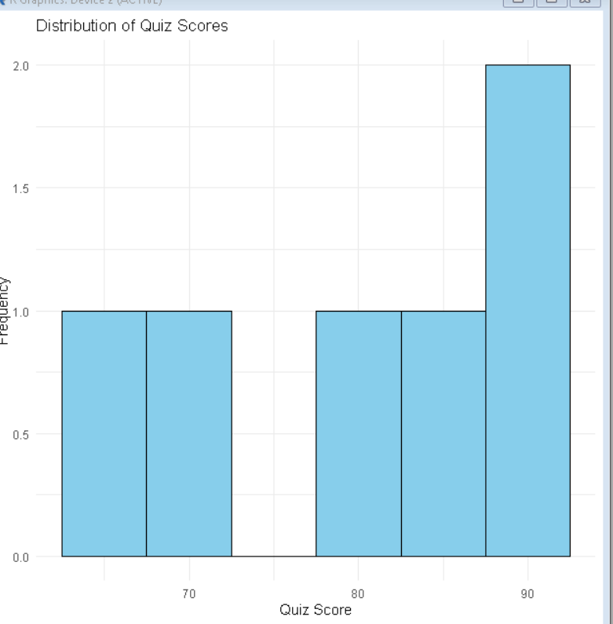
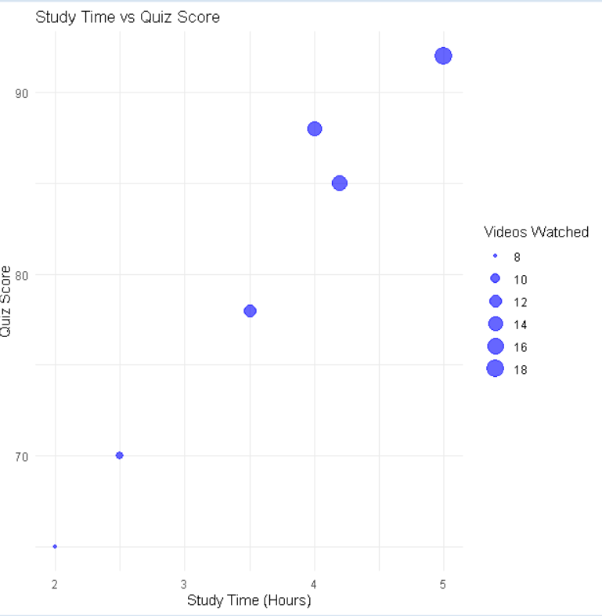

Question 2: Bubble Scatter Plot
R PROGRAM:

library(ggplot2)

data <- read.csv("Online_Learning_Activity.csv") ggplot(data,
aes(x = Study_Time, y = Quiz_Score,
size = Videos_Watched)) + geom_point(alpha = 0.6,
color = "blue") +
labs(
title = "Study Time vs Quiz Score", x = "Study Time (Hours)",
y = "Quiz Score",
size = "Videos Watched"
) +
theme_minimal()

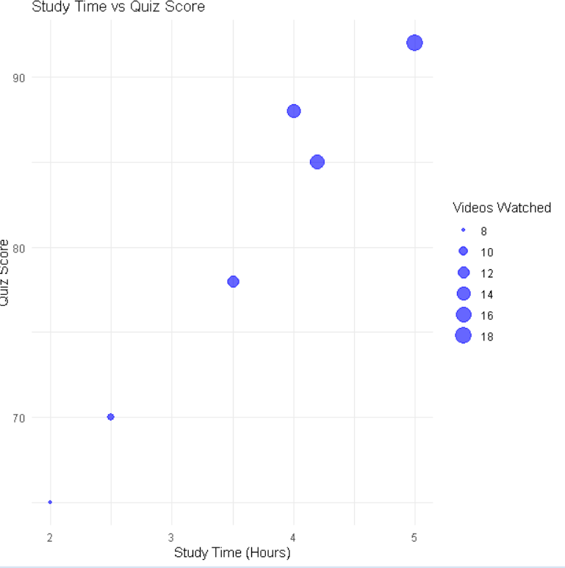

Question 3: Monthly Average Quiz Score with Moving Average R PROGRAM:
library(ggplot2) library(dplyr) library(zoo)
data <- read.csv("Online_Learning_Activity.csv") data$Login_Date <- as.Date(data$Login_Date) data$Month <- format(data$Login_Date, "%Y-%m") monthly <- data %>%
group_by(Month) %>% summarise(Average_Quiz = mean(Quiz_Score)) monthly$Moving_Average <- rollmean( monthly$Average_Quiz,
k = 2,
fill = NA,

align = "right"
)
ggplot(monthly, aes(x = Month,
y = Average_Quiz, group = 1)) +
geom_line(color = "blue", linewidth = 1.2) +

geom_point(size = 3,
color = "red") +

geom_line(aes(y = Moving_Average), color = "green",
linewidth = 1.2, linetype = "dashed") +

labs(
title = "Monthly Average Quiz Score", x = "Month",
y = "Average Quiz Score"
) +

theme_minimal()

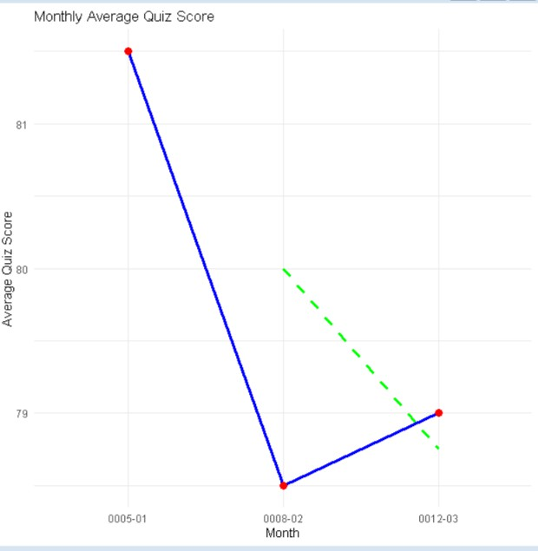

Question 4: Interactive Dashboard (Shiny + Plotly) R PROGRAM:
library(shiny) library(plotly)
data <- read.csv("Online_Learning_Activity.csv") ui <- fluidPage(
titlePanel("Online Learning Dashboard"), sidebarLayout(
sidebarPanel( selectInput(
"gender", "Select Gender",
choices = c("All",
unique(data$Gender))
),

selectInput( "course", "Select Course",
choices = c("All",

unique(data$Course))
)

),
mainPanel( plotlyOutput("barPlot"), br(),plotlyOutput("scatterPlot")

)

)

)

server <- function(input, output){

filtered <- reactive({

df <- data

if(input$gender != "All")
df <- df[df$Gender == input$gender,]

if(input$course != "All")
df <- df[df$Course == input$course,]

df

})

output$barPlot <- renderPlotly({

avg <- aggregate( Quiz_Score ~ Course, data = filtered(), mean
)

plot_ly( avg,
x = ~Course,
y = ~Quiz_Score, type = "bar", color = ~Course
)

})output$scatterPlot <- renderPlotly({ plot_ly( filtered(),
x = ~Study_Time, y = ~Quiz_Score, type = "scatter", mode = "markers",
size = ~Videos_Watched, color = ~Course
)
})
}
shinyApp(ui, server)

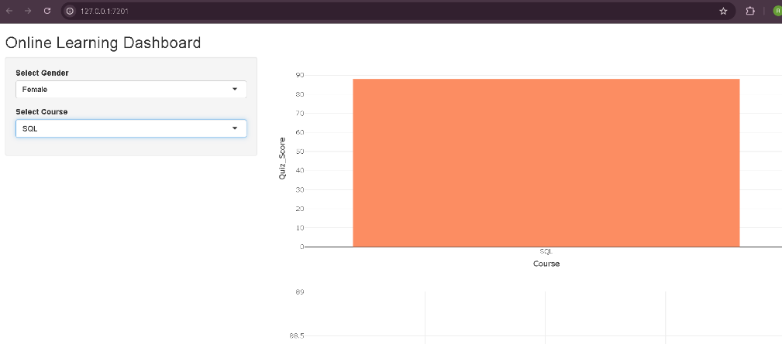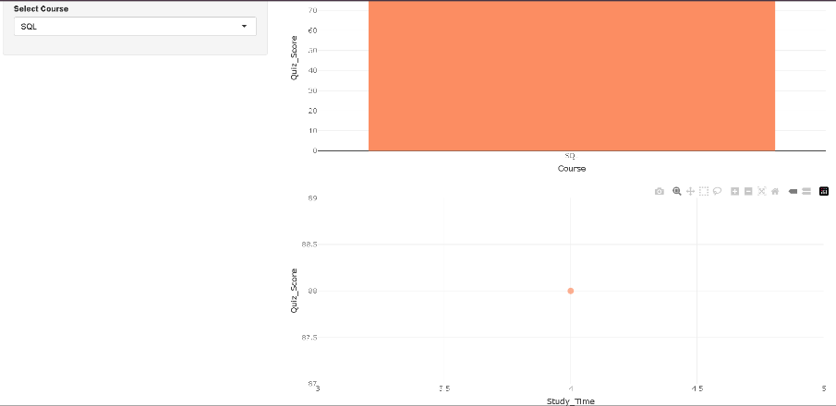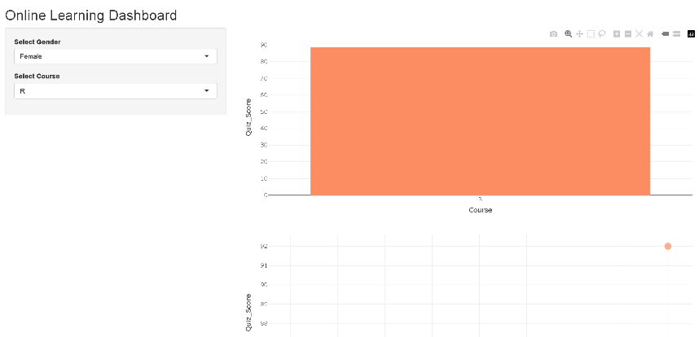
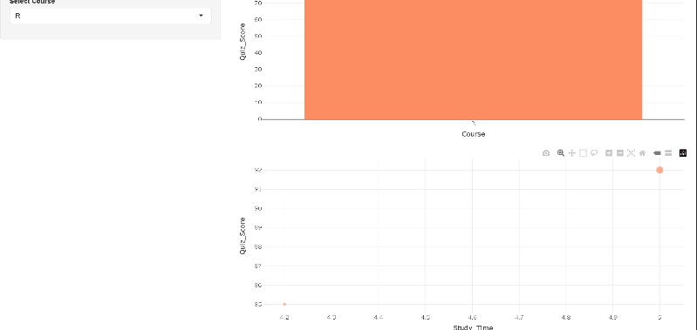

SET -10

Question 1: Grouped Bar Chart - Question 1 Responses
library(ggplot2) survey <- data.frame( SurveyID = c(1,2,3),

Question1 = c("A","B","C"),
Question2 = c("B","A","A"),
Question3 = c("C","D","B")
)
q1_count <- as.data.frame(table(survey$Question1)) colnames(q1_count) <- c("Answer","Count") ggplot(q1_count,
aes(x = Answer, y = Count,
fill = Answer)) + geom_bar(stat = "identity",
position = "dodge") +
labs(
title = "Distribution of Responses for Question 1", x = "Answer Option",
y = "Number of Responses"
) +
theme_minimal()

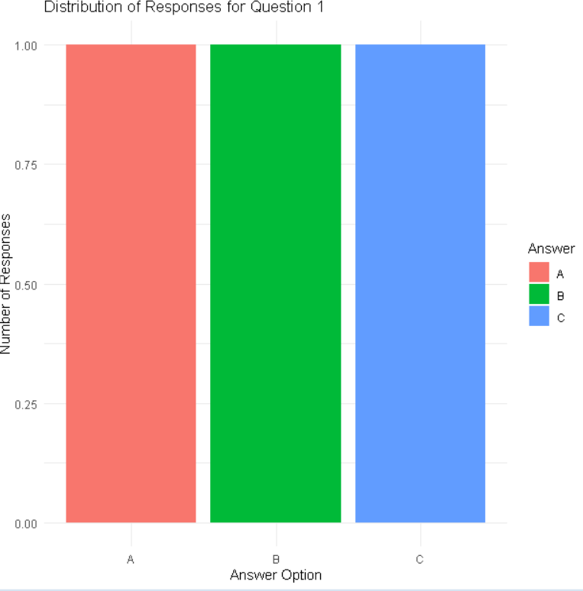

# Question 2

library(ggplot2) library(tidyr)
survey <- data.frame( SurveyID = c(1,2,3), Question1 = c("A","B","C"),
Question2 = c("B","A","A"),
Question3 = c("C","D","B")
)

survey_long <- pivot_longer( survey,
cols = Question1:Question3, names_to = "Question", values_to = "Answer"
)

ggplot(survey_long, aes(x = Question,
fill = Answer)) + geom_bar() +
labs(
title = "Overall Distribution of Survey Responses", x = "Questions",
y = "Number of Responses"
) +
theme_minimal()
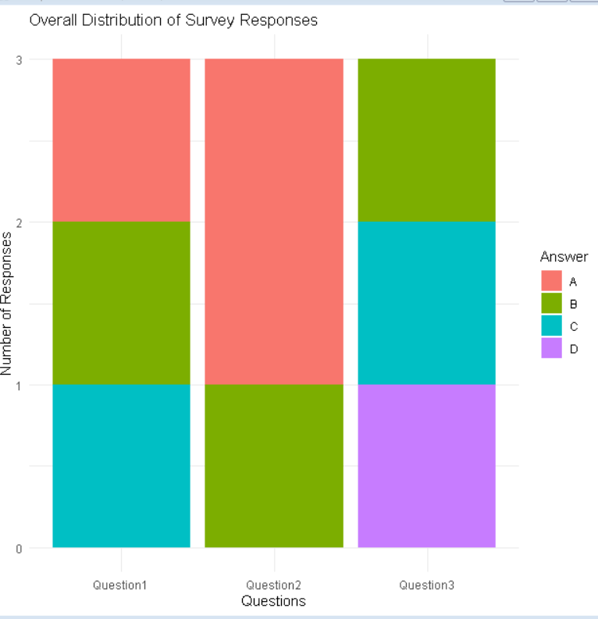

Question 3: Survey Response Table R program:
survey <- data.frame( SurveyID = c(1,2,3), Question1 = c("A","B","C"),
Question2 = c("B","A","A"),
Question3 = c("C","D","B")
)
print(survey)
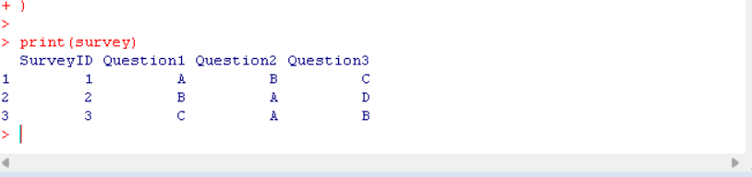
Question 4: Interactive Dashboard (Shiny + Plotly) R PROGRAM:
library(shiny) library(plotly) library(tidyr)
survey <- data.frame( SurveyID = c(1,2,3), Question1 = c("A","B","C"),
Question2 = c("B","A","A"),
Question3 = c("C","D","B")
)
q1_count <- as.data.frame(table(survey$Question1)) colnames(q1_count) <- c("Answer","Count")

survey_long <- pivot_longer( survey,

cols = Question1:Question3, names_to = "Question", values_to = "Answer"
)
response_count <- as.data.frame(table(survey_long$Question,
survey_long$Answer)) colnames(response_count) <- c("Question","Answer","Count")

ui <- fluidPage(
titlePanel("Survey Responses Dashboard"), fluidRow(
column( 6,
plotlyOutput("groupBar")
),
column( 6,
plotlyOutput("stackBar")
)
),
br(), tableOutput("surveyTable")
)
server <- function(input, output){ output$groupBar <- renderPlotly({ plot_ly(
q1_count,
x = ~Answer, y = ~Count, type = "bar",

color = ~Answer
)
})
output$stackBar <- renderPlotly({ plot_ly(
response_count, x = ~Question, y = ~Count,
color = ~Answer, type = "bar"
) %>%
layout(barmode = "stack")
})
output$surveyTable <- renderTable({ survey
})
}
shinyApp(ui, server)
